Exploratory Data Analysis (EDA) Project
Dataset: Diamonds — ~54,000 diamonds with cut, color, clarity, carat & price

1. Objective
This project explores the diamonds dataset — 53,940 records describing diamond attributes (carat weight, cut, color, clarity, physical dimensions) and price — to uncover the statistical patterns and relationships that drive diamond pricing, using descriptive statistics and visualization rather than predictive modeling.

2. Dataset Overview & Data Quality
Check | Result
Raw rows | 53,940
Columns | 10 (7 numeric, 3 categorical)
Missing values | 0
Duplicate rows | 146 (kept — plausible for identically-graded stones)
Rows with impossible 0 dimensions | 20 (dropped before analysis)
Rows used for analysis | 53,920

3. Statistical Summary
Key descriptive statistics for the numeric fields:
Feature | Mean | Std Dev | Min | Median | Max
Carat | 0.80 | 0.47 | 0.20 | 0.70 | 5.01
Depth % | 61.75 | 1.43 | 43.0 | 61.80 | 79.0
Table % | 57.46 | 2.23 | 43.0 | 57.00 | 95.0
Price ($) | 3,932.80 | 3,989.44 | 326 | 2,401 | 18,823

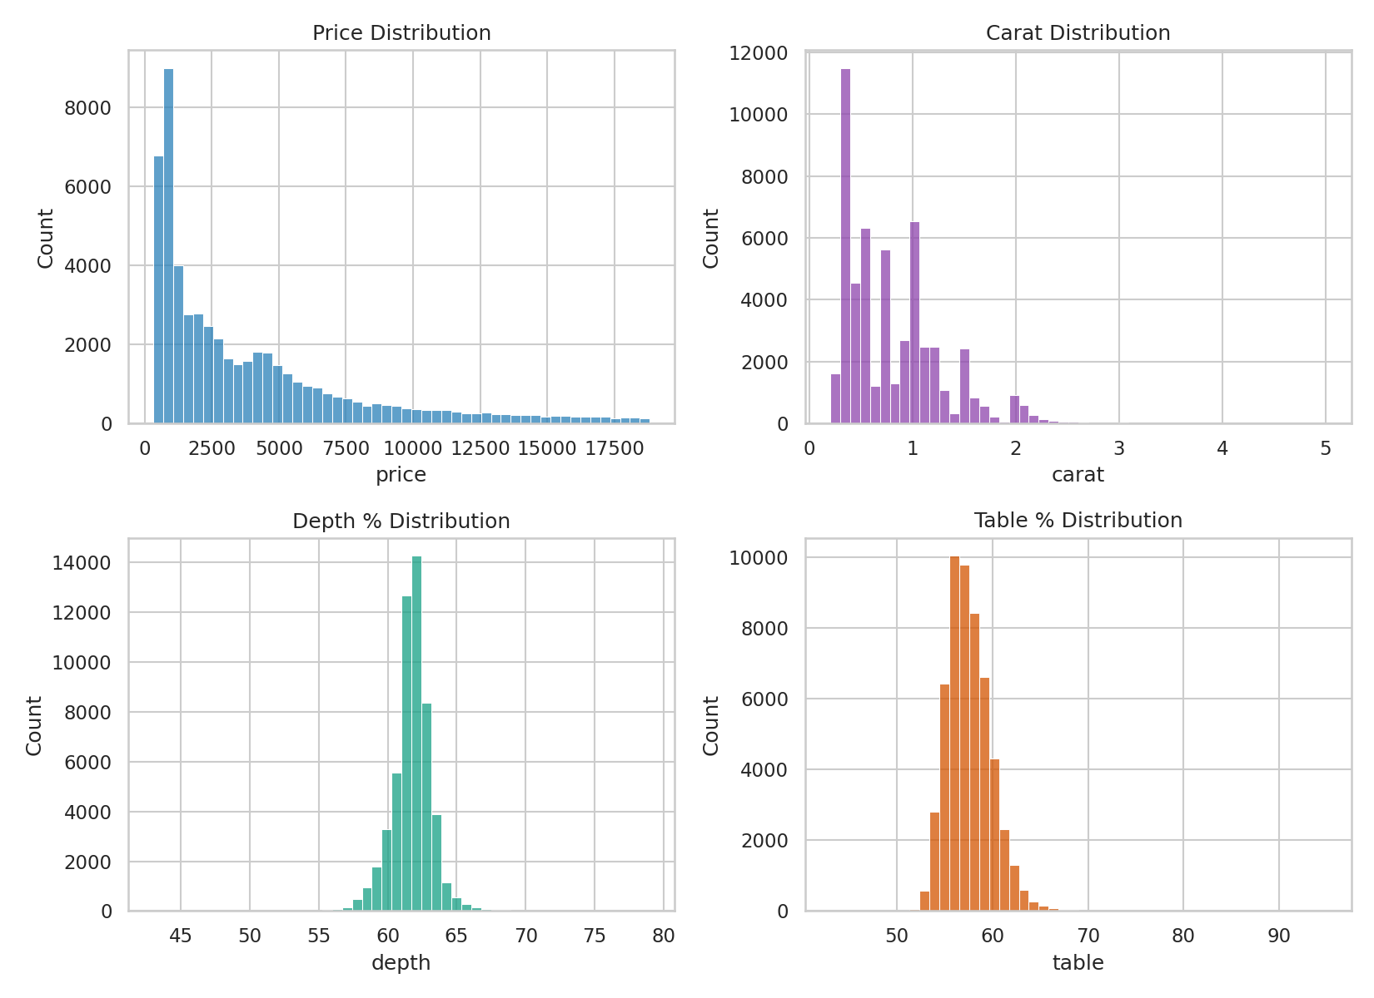
Figure 1 — Distributions of price, carat, depth %, and table %
Price is heavily right-skewed — most diamonds cluster under $5,000, with a long tail of expensive stones. Carat follows a similar pattern (most stones are under 1 carat), while depth and table percentage are much more tightly and symmetrically distributed, since these are cut-precision measurements with an optimal narrow range.

4. Correlation Analysis
Correlating each numeric feature against price reveals which physical attributes matter most:
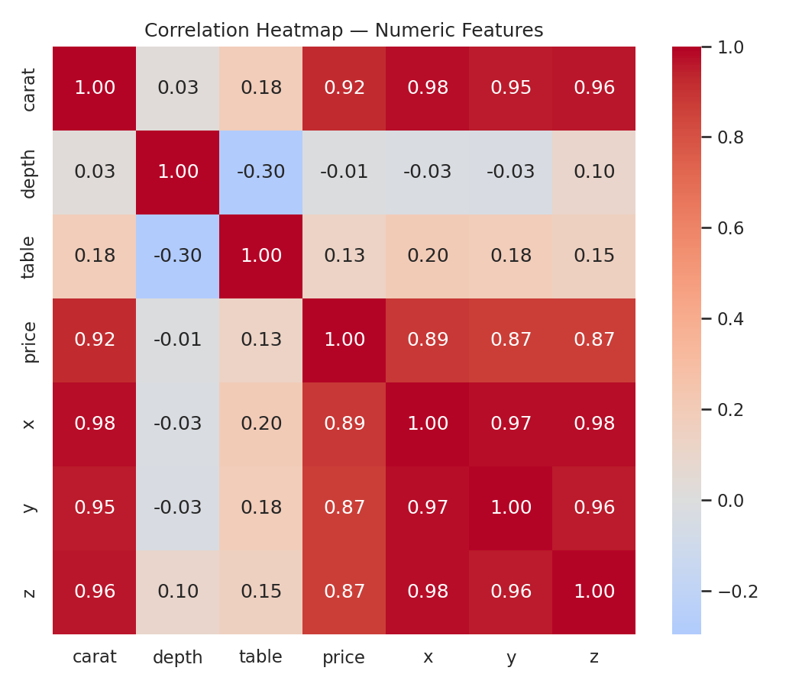
Figure 2 — Correlation heatmap of numeric features
Feature | Correlation with Price
Carat | +0.922
x (length, mm) | +0.887
z (depth, mm) | +0.868
y (width, mm) | +0.868
Table % | +0.127
Depth % | -0.011

Carat weight is overwhelmingly the strongest driver of price (r = 0.92) — far more influential than any other numeric attribute. This makes physical sense: a diamond's size largely determines its value before quality grading is even considered.

5. Carat vs. Price
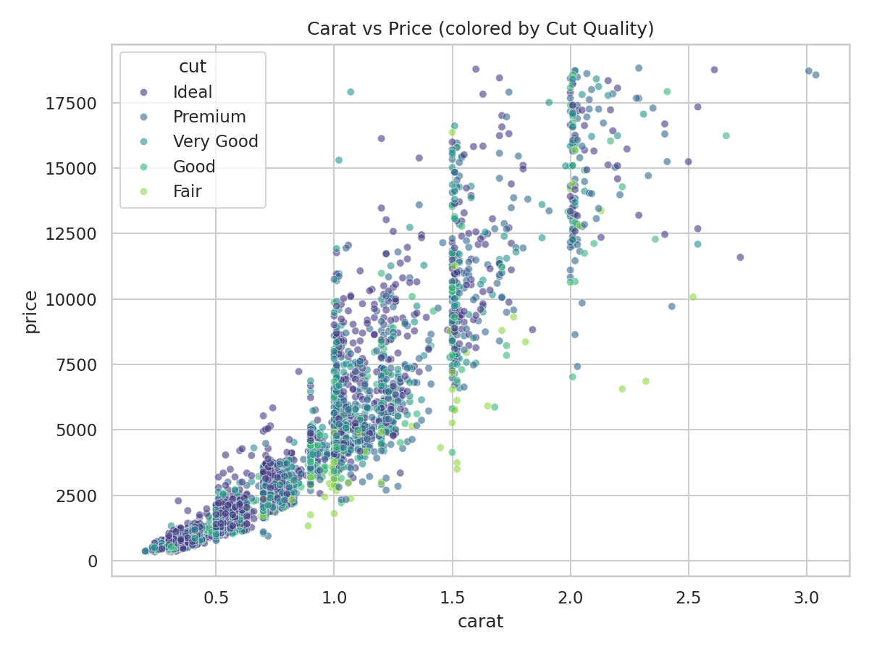
Figure 3 — Carat vs price, colored by cut quality
The relationship is clearly non-linear — price accelerates faster than carat weight increases, especially past 1–1.5 carats, reflecting the market premium on larger, rarer stones. Within any given carat size, better cuts (Ideal, Premium) trend toward the higher end of the price range.

6. Price by Quality Grade (Cut, Color, Clarity)
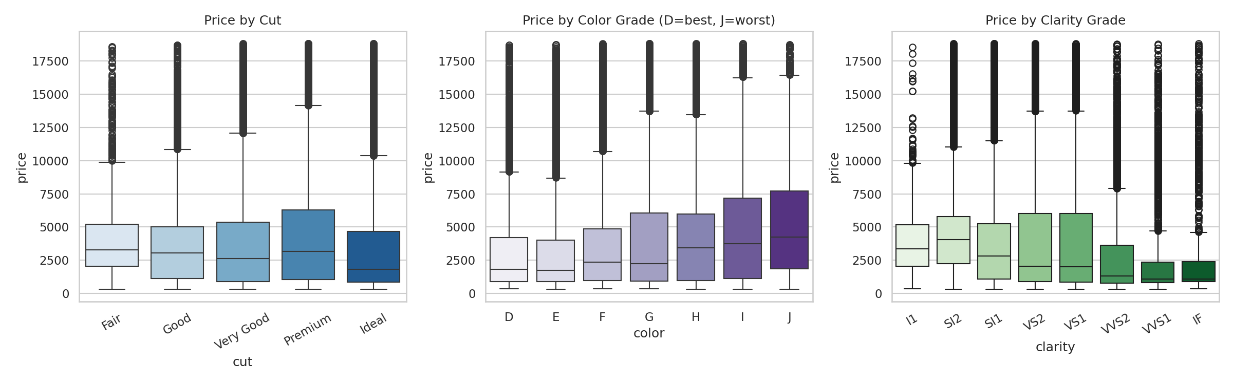
Figure 4 — Price distribution by cut, color, and clarity grade
Counter-intuitively, raw price does not increase monotonically with better cut, color, or clarity grades — 'Fair' cut and lower color/clarity grades sometimes show similar or higher median prices than 'better' grades. This is because these box plots mix diamonds of all sizes: larger, lower-grade stones can still outprice smaller, high-grade ones.

6.1 Isolating the Cut Effect (Price per Carat)
To see cut quality's true effect, we normalize by dividing price by carat weight:
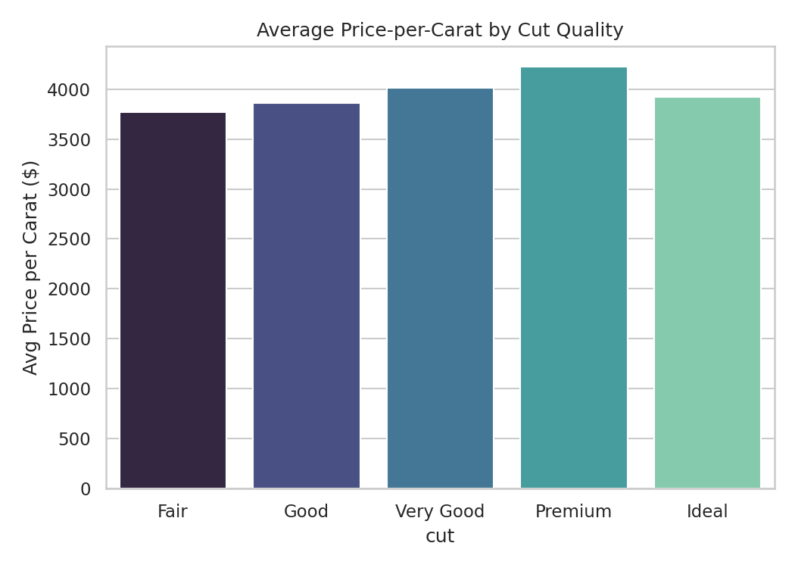
Figure 5 — Average price-per-carat by cut quality
Once size is controlled for, the expected pattern emerges: 'Premium' cut diamonds command the highest average price per carat (~$4,221), while 'Fair' cut diamonds have the lowest (~$3,766). Cut quality does matter — its effect is simply smaller than, and easily masked by, the dominant influence of carat weight.

7. Key Takeaways
- Carat weight is the single strongest predictor of diamond price (r = 0.92), dwarfing the influence of cut, color, and clarity.
- Price grows non-linearly with carat — larger stones carry a disproportionate premium.
- Cut quality has a real but modest effect, visible only after normalizing for carat weight (price per carat).
- Depth % and table % (precision-cut proportions) show almost no direct correlation with price — they matter more for visual brilliance than for price itself.
- 20 records had physically impossible zero dimensions and were excluded as data-quality issues.

8. Conclusion
This EDA confirms that diamond pricing is driven overwhelmingly by size (carat), with quality grades (cut, color, clarity) playing a secondary, refining role that only becomes visible once size is statistically controlled for. These findings would inform a predictive pricing model by prioritizing carat and physical dimensions as primary features, with categorical quality grades as secondary adjustors — exactly the kind of insight EDA is meant to surface before modeling begins.
Deliverables accompanying this report: the full Python EDA script (eda_project.py), summary statistics (summary_statistics.csv), and an interactive HTML dashboard.

